**Kirchhoff’s law**

Kirchhoff’s current law (KCL) states that the algebraic sum of the

currents entering and leaving an area, system, or junction is zero.

**KCL:**  i1+i2+i3….in = 0

Kirchhoff’s voltage law (KVL) states that the algebraic sum of the

potential rises and drops around a closed loop (or path) is zero.

**KVL:**  E1+E2+E3….En = 0

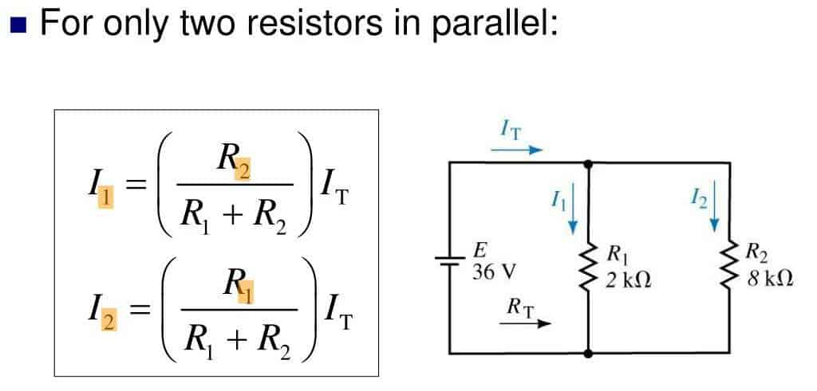

* Current Divider Rule:
* 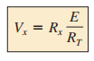Voltage Divider Rule:

Rt= Total Registence.

**Super Position Theory**

The current through, or voltage across, an element in a linear

bilateral network is equal to the **algebraic sum** of the currents or

voltages produced independently by **each source.**

* Remove a voltage source_(short circuit).
* Removing a current source_(open circuit).
* Any internal resistance or conductance_must still be considered.
* Calculate **current** or **volt** for target component and make algebraic sum.

*The superposition principle is not applicable to power effects since

the power loss in a resistor varies as the square (nonlinear) of the

current or voltage.

**Thévenin’s theorem**

Any two-terminal, linear bilateral dc network can be replaced by an

equivalent circuit consisting of a **voltage source** and a **series resistor**.

1. **RL** to be temporarily removed from the network.
2. Find **RTh**:

* voltage sources are replaced by short circuits, keep internal resistance of sources.
* current sources by open Circuits.
* calculate resistance between the two marked terminals.

1. Find **Vth:** Calculate the volt between two marked point.

Use the formula,

$$I=\frac{Vth}{Rth + Rl}$$

**Norton’s theorem**

Any two-terminal linear bilateral dc network can be replaced by an

equivalent circuit consisting of a **current source** and a **parallel**

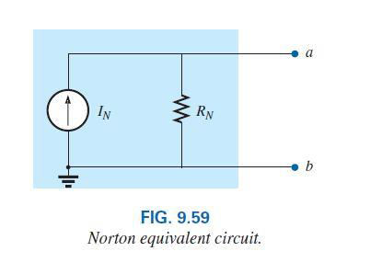**Resistor**.

1. **RL** to be temporarily removed from the network.
2. Find **RN**: (**RTh = RN)**

* voltage sources are replaced by short circuits, keep internal resistance of sources.
* current sources by open Circuits.
* calculate resistance **RN** between the two marked terminals.

1. Find **VN:** Calculate the volt between two marked point.
2. Calculate **IN** by first returning all sources to their original position

and then finding the **short-circuit current** between the marked

terminals.

*IN*

**Maximum power transfer theorem**

A load will receive maximum power from a linear bilateral dc

network when its total resistive value is exactly equal to the Thévenin’s resistance of the network as “seen” by the load.

**RL = RTH = RN**

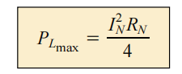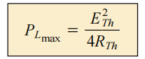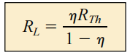

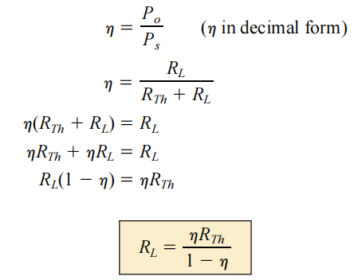

A list of the advantages of alternating current:

• Easy to be transformed (step up or step down using a

transformer).

• Easier to convert from AC to DC than from DC to AC.

• Easier to generate.

• It can be transmitted at high voltage and low current over

long distances with less energy lost.

• High frequency used in AC makes it suitable for motors.

* The amount of electric current traveling per unit cross-section area is called as current density and expressed in amperes per square meter.
* [Resistivity](https://www.toppr.com/guides/physics/current-electricity/resistivity-various-materials/) refers to the electrical [resistance](https://www.toppr.com/guides/physics/current-eletricity/drift-electrons-origin-resistivity/) of a conductor of a particular unit cross-sectional area and unit length. It is definitely a characteristic property of each material.
* A capacitor is a two-terminal electrical device that can store energy in the form of an electric charge.
* An **electric dipole** is a separation of positive and negative charges.  
  The electric dipole moment is the product of the magnitude of the charge and the distance between the centers of positive and negative charges.
* The emf or voltage whose magnitude changes sinusoidal with time is known as alternating emf and is represented by the relation  
   E=E0sin(ωt)
* The average velocity of charged particles in a material due to an electric field is known as drift velocity.
* To put this relationship between voltage and current in a capacitor in calculus terms, the current through a capacitor is the derivative of the voltage across the capacitor with respect to time.
* The meaning of time constant is the time taken by the capacitor to be charged to about 63.2% of its full value through a resistor connected to it in series.

**Permittivity** is a measure of polarizability of a dielectric.

The permittivity of the material between the capacitor's plates determines how much electric field can be established for a given voltage across the plates.

**Electric displacement,** denoted by D, is the charge per unit area that would be displaced across a layer of conductor placed across an electric field. It is also known as electric flux density.

The total number of electric field lines passing a given area in a unit of time is defined as the **electric flux.**